 | Guidance for Team Captains  and Assorted Others  v0.1 - Autumn 2025

Introduction
This guide is a work in progress, new for the 2025-26 season. Doubtless it will need to change over time both to improve it in various ways and to reflect changes in the BACL rules and changes in the way the ECF LMS functions.
The BACL rules available via our website: https://www.buryleaguechess.org/documents.
Captain’s should be familiar with the rules, especially any changes from the previous season, for which you may find it useful to read the minutes of the most recent AGM, available from the same area of our website. The most pressing sections for new captains are:
- 3. Teams
- 4. Playing Times
- 5. Ratings, Board Order and Eligibility
- 6. General Match Rules
- 8. Rearranged Matches
We will reference some of the league rules in this guide.
Who is this Guide For ?
Different chess clubs operate in different ways. However, all teams from all clubs are expected to have team captains. The duties of a captain may vary but any or all the following may be in their remit. Please check with your club’s leadership as to which of them they expect you to do, and which they will do centrally for your club as a whole.
- Acting as the as a point of contact for about matters relating to the team.
- Reporting or confirming match results in the ECF League Management System (LMS).
- Distributing the fixture list for the team to those who are likely to be playing during the season.
- Organising who will be playing for their team in any given match, and in what board order.
- Confirming travel arrangements.
- Communicating with opposing captains about match arrangements.
- Adding new players to the LMS. Providing estimated ratings for new players.
This guide will not be addressing all of these areas. It will focus primarily on the use of the LMS, but will also touch on other areas we know have often caused problems.
If captains are not in attendance at any of their teams fixtures, they should be sure to communicate the relevant responsibilities to an “acting captain” for the match.
LMS User Accounts
All captains must have LMS accounts. Before the start of each season, clubs should provide a list of teams and their captains to the BACL Match Secretary and Internet Officer. Depending on how responsibilities within the club are allocated, clubs may also find it useful for some other club officials to have LMS accounts. All captains, along with any other club LMS users will be able to enter and confirm results for all of the clubs teams. They will also be able to add new players to their list.
For new LMS users, please provide the following information:
- Email address
- First name
- Last name
- Middle Initial(s) and/or Year of Birth
If the last seems surprising, remember that some names are more common than others and the LMS is used all across the country. The extra details may be included in the user name allocated in order to make it unique.
Account creation is carried out by a central team and not by the league officers. We forward the details along all in a big batch to avoid having to contact them too often. Once the users have had their account created, they will receive an email from the LMS admin team with details of how to log in.
New users should update their contact details within their LMS account. These details will be visible to all other logged in users within BACL. Similarly, when you log in you’ll be able to see the email address and phone numbers of other team captains and league officials. Obviously anyone whose phone number or email address has changed should also update their details in this part of the system.

Terminology – Player Lists vs Nominations
Within the LMS each club has a set of players that are available to pick from as the people who played in a given match. This is the club’s “player list”. Anyone who plays for your club must be on your club’s list. Clubs may have multiple player lists if they play as part of multiple leagues or other competitions.
In addition to a club’s list of players in the LMS, each team within a club must have a list of nominated players. Although we display this in the LMS (at the bottom of our main LMS page, here), the LMS system itself doesn’t have any functionality related to this. Unless specifically indicated, where we refer to “player lists” in this guide, we mean the list of players that the LMS shows as available to select from as the players in a match, and not the list of nominated players.

Adding New Players
BACL Rule 3.4
Clubs should add new players to their player list in the ECF Leam Management System. Ideally this should be done before their first game.
Team captains and other LMS users within the club can add players to the player list. Note that a club will have at least one player list for each league in which they compete. In some cases therefore players have to be added multiple times.
When setting up new players it is advisable to begin the process by searching for the player on the ECF Rating Database. Search by surname. You should also check the “unrated” players. People who have only just started playing but have taken out their ECF membership, along with players who are returning to chess after a time away, are likely to appear here. Where there are several entries with the same name or initials as your player, it may help to look at their game history as stored in the LMS. Ask the player if any of the candidate records look like theirs. Send them links to the ones you think might be them and ask them to confirm.
Once you’ve confirmed which record is theirs or are sure that there is no existing ECF rating record for them, you’re ready to begin the process in the LMS.
From the BACL’s main “home page” within the LMS (here), click on “Clubs” on the top menu, then select your club. If you’re logged in and have the relevant permissions, you’ll see the following tabs. Select the “Players” tab.
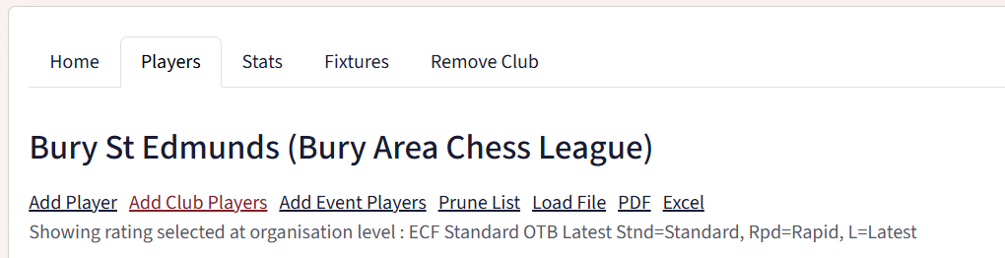
The options are not well named. In almost all cases you’ll want to choose “Add Player”.
The other options allow you to duplicate all the players from another club or event into your list of players. This can be useful if you are using the LMS to administer an internal club event that is using it’s own player list and you want to copy from a previous edition to the latest one … or if two clubs are merging or holding a combined event. But for general purposes you simply want to add a single player.

You’ll be presented with the following screen:
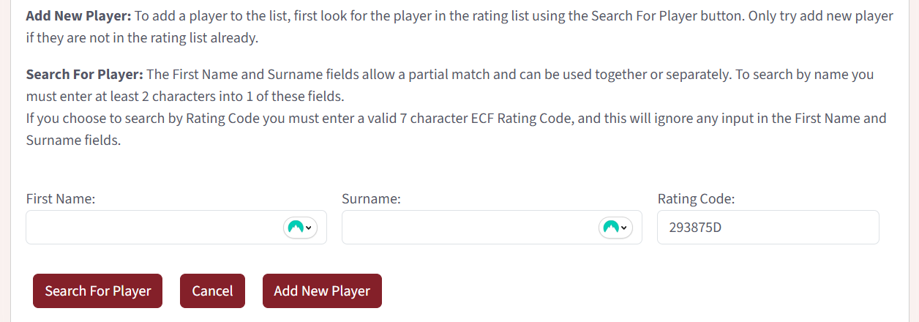
You don’t need to fill in all the boxes. If you’ve found the player in the ECF rating database, the most reliable option is to enter their Rating Code. This will be something like “293875D”. Enter the details you’re search for and hit “Search For Player”
You’ll be shown a list of matching entries from the ECF ratings system. You can add any of those to your player list by clicking on their First Name or ECF Code (these are underlined)
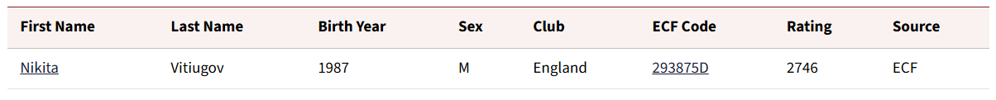
If there is no match (and you’ve checked alternative spellings), press “Add New Player”. The form that appears is fairly straight forward. Fill in all the details you know. The “Local” ratings are where you can supply estimates. Note that a zero in these fields does not indicate an estimate of zero. It indicates that no estimate has been supplied.
Estimates should be agreed in advance with our Ratings Officer (Bob Jones), but if you don’t have them, or have not agreed them at the time you are creating the record, you can still go ahead and then alter the local ratings later if necessary, on which see below.

Updating Estimated (Local) Ratings
BACL Rule 5.5 [Excerpt]
Where a player has no published standard OTB rating, the club secretary will provide the … an estimated rating, which should be used for the purposes of these rules.
For completely new players, players without an ECF rating and players with only a P-suffixed “partial rating” an estimate needs to be agreed with the league ratings officer (Bob Jones at the time of writing. This agreed estimate should be entered into the “Local Rating” field. These ratings, which appear L-suffixed in the LMS should be reviewed at least annually. They may be periodically cleared by the Internet Officer to allow the ECF’s own rating to automatically take precedence where one has been calculated.
Navigate to the Player List for your club. Click on the player’s first name. You’ll be shown all their details, but you can’t immediately edit them. You’ll need to switch to the Edit tab.

Here you can supply or update local ratings in the same way as when first creating the player record.

Housekeeping
In addition to gaining new members, clubs also lose members. To ease administration it makes sense for clubs to occasionally remove players from their player lists.
You can do this manually one at a time from your player list. The “bin” icon at the left of each record can be used for this. Or if you are between seasons and haven’t yet added any new players, the options within “Prune List” may be useful. Please use that with care, if you remove players that should have been retained, they will simply need to be readded manually.
Just as clubs which compete in multiple leagues may have to add players to each player list separately, they may also need to remove them from each separately.

Nominations, Eligibility and Board Order
The league rules use (original) August ratings (K or A suffixed) for nominations, for comparison to nominated board ratings and for calculating aggregate ratings for the Roger Goldsmith competitions.
However, once the eligibility of a group of players has been determined, the order in which they play is based upon the latest ratings (K or A suffixed). There is a tolerance of 100 rating points permitted. New and junior players are especially likely to have rapidly changing ratings. Latest ratings can always be found via the ECF Rating Database: https://rating.englishchess.org.uk/v2/new/list_players.php
In addition to searching for players individually by last name, you can search for your club, which can be useful if you have multiple players to check.

Match Postponements
BACL Rule 8.6
Team captains shall notify the Match Secretary and Internet Officer immediately a match is postponed and when it is rearranged.

The date shown for the match in the LMS must reflect the best current information as to when the match will be played (or was played). It is not acceptable for a match not to be played on the date shown in the LMS and for no contact to be made with the Match Secretary and Internet Officer.
In the event that no new date has been fixed, that should also be communicated … though this should be rare as in all but the most exceptional cases the rules require the new date to be decided upon before the originally scheduled date has passed.
Captains cannot alter the dates of matches themselves. This has to be done by the Match Secretary or Internet Officer. Reporting a result against a date other than the one it was actually played on can make a material difference to player ratings. This can cause a ripple effect to players quite distant to the ones involved in the postponed match.

Match Results Entry and Confirmation
BACL Rule 6.2
Captains should exchange lists of their players before the match starts, with forename, surname and rating.
BACL Rule 6.8
Captains of both teams should enter or confirm the match result on the ECF’s League Management System (LMS). Where possible this should be done within two days of the fixture, and in any case within a week. On request the Internet Officer may grant other club officials permission to enter and confirm results on behalf of team captains.

While the formal exchange of lists of players before a match starts is not generally expected, the rule remains in place because it’s important that the captains or acting captains know who all the players involved in the match are. It will not be possible to enter or confirm the match result unless these details are known.
Failure to report a result accurately or in a timely way can make a material difference to player ratings.
It should go without saying that it’s also essential that the captain (or acting captain) of each team knows the results of all the games. Players should not leave the venue without communicating their result in some fashion.

Entry and Confirmation Processes
The LMS gives several ways to navigate to the relevant parts of the system. Mostly the process is about finding the correct match, clicking on the match score and filling out the necessary details. The following is one way of going about the process.
When logged into the LMS, click on your username at the top right to reveal this sub-menu:
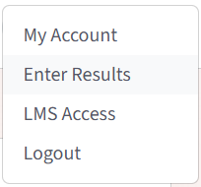
Click on Enter Results.

You’ll be taken to the “My Fixtures” page. The first paragraph of text should read something like the following:
Welcome user Steve Lovell. You have access to update match results for the following clubs: Bury St Edmunds, A list of recent fixtures is shown below that have not had any score entered yet and are for one of the clubs listed above. Pick on the one you want to update. To see all the fixtures for a club, pick on its name above.

Anything very different to this most likely indicates that you don’t have the necessary permissions.
At the time of writing, I have no examples to take screenshots of, however, I believe the top section will list any matches that do not yet have a result and which you are eligible to enter, and the second section will list matches that have a result which has been recently entered and which you are eligible to confirm.
Click on the match score, which will be 0-0 for anything in the top section.
You’ll be taken to a page that looks something like this:
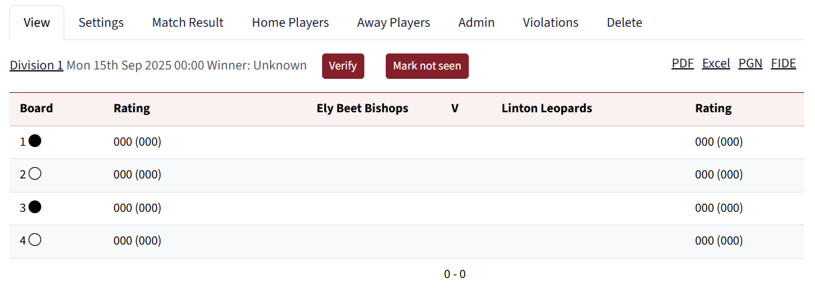
To add the players and the game results click on the “Match Result” tab. You must supply details for all the players on both teams and results for all boards. If a player is not available in your list, then you can add them via the “Home Players” or “Away Players” tab. Please see the section on Adding New Players for additional guidance. You will not be able to add players for your opponent’s team list (unless they are another team in your club). So if the relevant players isn’t in the list, it may make sense to wait for the opposing captain to enter the result and then for you to confirm it instead. Alternatively, pick the option “New Player”.
Where a game is defaulted, you should use the results which include the text “0 (def)”. Only such games should have the player listed as “Default”. However, the winning side should name the player who would have played. Amongst other things, that can help players meeting the minimum game thresholds for the Player of the Season competition.

If the opposing captain gets to the match first, and everything is complete and correct, then you can simply click the verify button. If something is wrong, you may be able to amend it, but it’s likely that you will not have permission to do this. If you amend anything, it will then go back to the person who originally entered for them to verify. If you cannot change what needs to be changed, then you should contact the Match Secretary and Internet Officer who will make the changes on your behalf. You should copy the opposing captain into any such communication.

A Note on Contacting the Match Secretary and Internet Officer
While it can be helpful for captains to add comments to matches indicating any changes to the match that may be necessary, this does not constitute communication with the Match Secretary or Internet Officer. They will receive no notification that such comments have been added to the match. Please send them an email using their details as displayed within the Captains section on the LMS (contact details only show when you have logged in).

Get in touch about errors and omissions in this guide.
If there are elements of the LMS that you feel need adding to this guide, or which are already featured here but where the guidance could be improved, please get in touch with me, Steve Lovell, Internet Officer. My contact details are available in the LMS “Captains” section. Alternatively, I can be reached via the contact form on the league website.

Useful Links

- The LMS: https://lms.englishchess.org.uk/lms/
- The BACL home within the LMS: https://lms.englishchess.org.uk/lms/organisation/666
- BACL Contact Details: https://lms.englishchess.org.uk/lms/organisation/666/captains
- The BACL Website: https://www.buryleaguechess.org/
- Club Contact Form: https://www.buryleaguechess.org/contact
- The ECF Ratings Database: https://rating.englishchess.org.uk/v2/new/list_players.php
- ECF Membership Information: https://www.englishchess.org.uk/ecf-membership-rates-and-joining-details/
- The ECF Membership System: https://ecf.justgo.com/
- The ECF Member Finder: https://ecf.justgo.com/MemberFinder.htm

